RING PROGRAM
BEGINNER 1
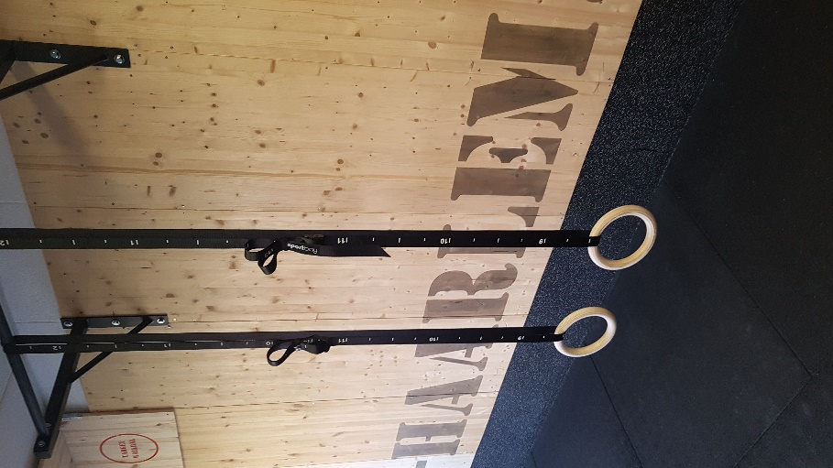

PROGRAM 1
WARMING-UP

Single set Static hold | TRAINING 1 | TRAINING 2 | TRAINING 3 | TRAINING 4 | TRAINING 5 | TRAINING 6
1 push up hold up | 4x 20/30 | 4x 25/35 | 4x 30/35 | 5x 30/45 | 5x 34/45 | 5x 36/45
2 ring hold regular | 3x 10/35 | 3x 12/35 | 3x 14/35 | 4x 15/35 | 4x20/35 | 4x25/35
3 pullup hold down | 3x 10/35 | 3x 12/35 | 3x 14/35 | 4x 15/35 | 4x20/35 | 4x25/35
4 upside down hanging | 3x 10/35 | 3x 12/35 | 3x 14/35 | 4x 15/35 | 4x20/35 | 4x25/35

Single sets | TRAINING 1 | TRAINING 2 | TRAINING 3 | TRAINING 4 | TRAINING 5 | TRAINING 6
5 push ups | 4 sets max-1 | 4 sets max-1 | 5 sets max-1 | 5 sets max-1 | 6 sets max-1 | 6 sets max-1
6 austrailian row | 4 sets max-1 | 4 sets max-1 | 5 sets max-1 | 5 sets max-1 | 6 sets max-1 | 6 sets max-1
7 dipping behind the back | 4 sets max-1 | 4 sets max-1 | 5 sets max-1 | 5 sets max-1 | 6 sets max-1 | 6 sets max-1
8 regulair knee raises | 3x12 | 3x14 | 4x14 | 4x16 | 5x14 | 5x16

ABS Single sets | TRAINING 1 | TRAINING 2 | TRAINING 3 | TRAINING 4 | TRAINING 5 | TRAINING 6
9 Deadbug | 2x10 | 2x12 | 3x8 | 3x10 | 3x12 | 3x14
10 L-sit floor double leg raises | 3x5 | 3x6 | 3x7 | 4x5 | 4x6 | 4x7

