RING PROGRAM
BEGINNER 2
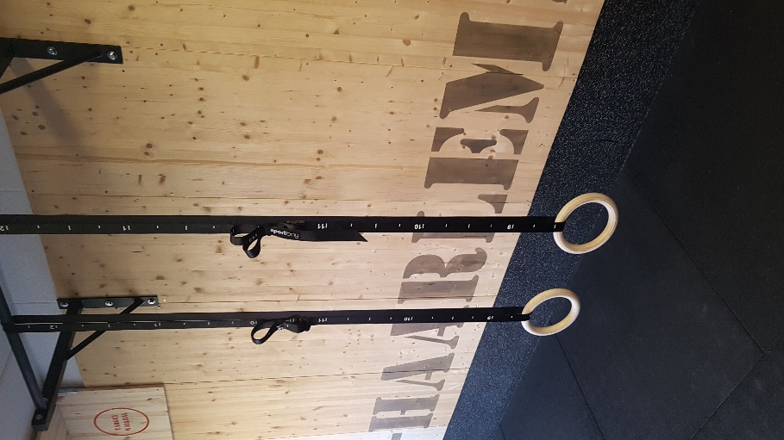
PROGRAM 2
WARMING-UP
Single set Static hold | TRAINING 1 | TRAINING 2 | TRAINING 3 | TRAINING 4 | TRAINING 5 | TRAINING 6
1. Chest schoulder stretch rings | 2x 10/30 | 3x 10/30 | 3x 12/30 | 3x 14/30 | 4x14/30 | 4x16/30
2 regulier hold | 3x 20/35 | 3x 24/35 | 3x 28/35 | 4x 20/35 | 4x24/35 | 4x26/35
3 push ups hold lag | 3x 10/35 | 3x 12/35 | 3x 14/35 | 4x 12/35 | 4x16/35 | 4x20/35
4 ching up hold half way | 4x 10/35 | 4x 12/35 | 4x 14/35 | 5x 10/35 | 5x 12/35 | 5x 14/35

SINGLE SET NEGATIVE | TRAINING 1 | TRAINING 2 | TRAINING 3 | TRAINING 4 | TRAINING 5 | TRAINING 6
5 dips | 3x 6 | 3x8 | 3x10 | 4x8 | 4x9 | 4x10
6 Pull ups | 3x 6 | 3x8 | 3x10 | 4x8 | 4x9 | 4x10

SINGLE SETS | TRAINING 1 | TRAINING 2 | TRAINING 3 | TRAINING 4 | TRAINING 5 | TRAINING 6
7 Push ups | 4x10 | 4x12 | 4x14 | 5x12 | 5x14 | 5x16
8 Australian row | 4x8 | 4x10 | 4x12 | 5x12 | 5x14 | 5x16
9 upside down pulls | 4x6 | 4x8 | 4x10 | 5x6 | 5x7 | 5x8

ABS | TRAINING 1 | TRAINING 2 | TRAINING 3 | TRAINING 4 | TRAINING 5 | TRAINING 6
10 Tabata superman & HBH | 4x 18/10 | 4x20/10 | 4x22/10 | 5x 18/10 | 5x20/10 | 5x22/10

