RING PROGRAM
BEGINNER 3
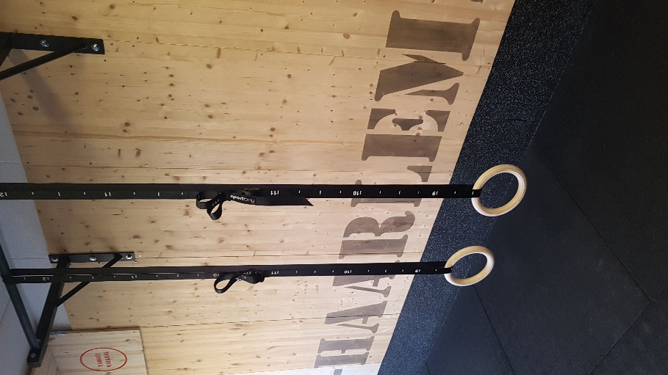
PROGRAM 3
WARMING-UP
EMOM SUPERSET STATIC HOLD | TRAINING 1 | TRAINING 2 | TRAINING 3 | TRAINING 4 | TRAINING 5 | TRAINING 6
1 Minutes 1 Pushup hold up | 4x 24s | 4x26 | 5x26 | 5x28 | 6x28 | 6x30
2 Minutes 2 pull ups hold up | 4x 14 | 4x16 | 5x16 | 5x18 | 6x18 | 6x20
3 Minutes 1 regulair hanging | 4x 24 | 4x 26 | 5x 28 | 5x 26 | 6x 28 | 6x 30
4 Minutes 2 upside down hanging | 4x 14 | 4x 16 | 5x 18 | 5x 14 | 6x 16 | 6x 18

SINGLE SET | TRAINING 1 | TRAINING 2 | TRAINING 3 | TRAINING 4 | TRAINING 5 | TRAINING 6
5 box chin ups | 3x6 | 3x8 | 3x10 | 4x6 | 4x8 | 4x10
6 box dips | 3x8 | 3x10 | 3x12 | 4x10 | 4x12 | 4x14
7 chest fly low position single arm | 3x6 | 3x8 | 3x10 | 4x6 | 4x8 | 4x10
8 Hanging knee raises | 3x12 | 3x14 | 4x14 | 4x16 | 5x14 | 5x16

ABS | TRAINING 1 | TRAINING 2 | TRAINING 3 | TRAINING 4 | TRAINING 5 | TRAINING 6
9 V-ups | 3x6 | 3x8 | 3x10 | 4x6 | 4x8 | 4x10
10 HBH | 3x 20/35 | 3x 24/35 | 3x 28/35 | 4x 20/35 | 4x24/35 | 4x26/35

