RING PROGRAM
MEDIUM 1
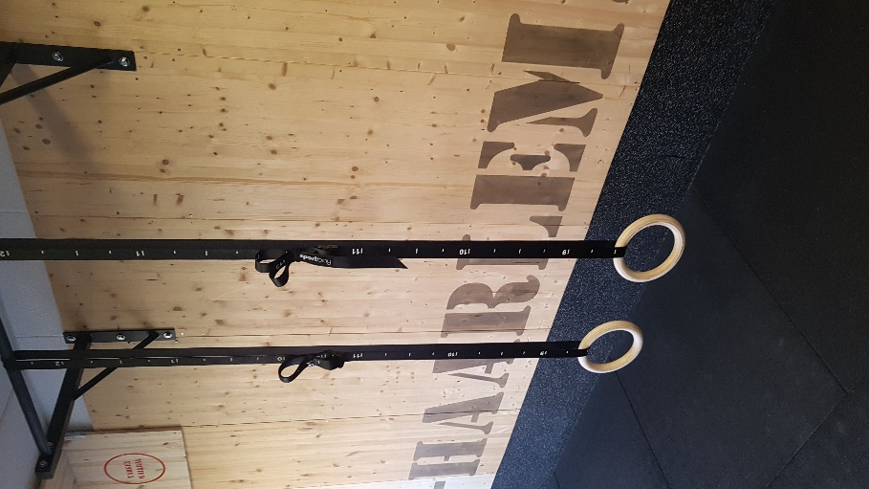
PROGRAM 1
WARMING-UP
SINGLE SETS | TRAINING 1 | TRAINING 2 | TRAINING 3 | TRAINING 4 | TRAINING 5 | TRAINING 6
ROTATIES PUSH UP | 2x10 | 2x12 | 2x14 | 3x10 | 3x12 | 3x14
ROTATIES DIP | 2x10 | 2x12 | 2x14 | 3x10 | 3x12 | 3x14
ROTATIES PULL UP | 2x10 | 2x12 | 2x14 | 3x10 | 3x12 | 3x14

SINGLE SETS | TRAINING 1 | TRAINING 2 | TRAINING 3 | TRAINING 4 | TRAINING 5 | TRAINING 6
CHEST AB EXERCISE | 3x10 | 3x12 | 3x14 | 4x10 | 4x12 | 4x14
FALS GRIP AUSTRAILIAN ROW | 3x10 | 3x12 | 3x14 | 4x10 | 4x12 | 4x14
HANGING ABS SINGLE LEG, LEG RAISES | 3x2x8 | 3x2x9 | 3x10 | 4x8 | 4x9 | 4x10
BACK EXTENSION UPSIDE DOWN HANGING | 3x10 | 3x12 | 3x14 | 4x10 | 4x12 | 4x14

NEGATIEF TRAINEN | TRAINING 1 | TRAINING 2 | TRAINING 3 | TRAINING 4 | TRAINING 5 | TRAINING 6
1 PUSH-UPS | 4x30/60 | 4x30/50 | 4x35/60 | 5x30/60 | 5x30/50 | 5x35/60
2 PULL-UPS | 4x30/60 | 4x30/50 | 4x35/60 | 5x30/60 | 5x30/50 | 5x35/60
3 DIPS | 4x30/60 | 4x30/50 | 4x35/60 | 5x30/60 | 5x30/50 | 5x35/60

