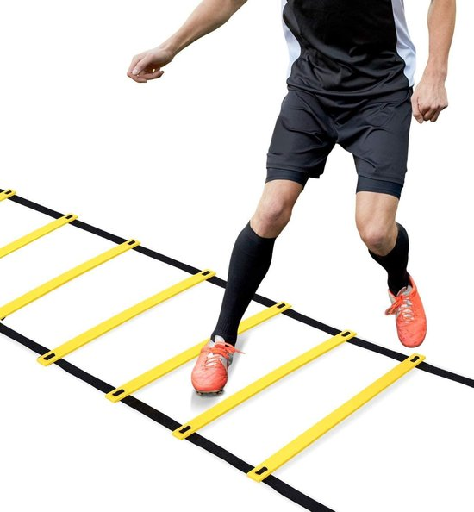
ABC PROGRAMMA 1
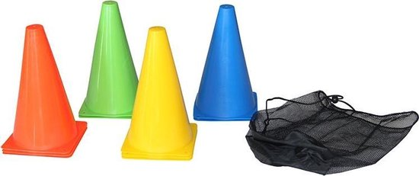
1 SPEEDLADDER FRONTAL JUMPING IN IN OUT OUT
2 GAIT JUMPS (LOOPSPRONGEN) 26 METER
2 CONE ZIGZAG DRILL SIDEWAYS 7 METER
3 SPEEDLADDER ICKY SHUFFLE
4 26M SIDE SHUFFLE TURN AROUND EVERY 6 METER
5 SHORT TO LONG STEP SPRINT DRILL UNTIL 26 METER
WORKOUT 1 WORKOUT 4
1X TEST 4X 40 SECONDS REST
2X 50 SECONDS REST
WORKOUT 2 WORKOUT 5
3X 50 SECONDS REST 2X 2 ROUNDS 60 SECONDS REST
WORKOUT 3 WORKOUT 6
3X 40 SECONDS REST 1X 3 ROUNDS 60 SECONDS REST
1X 2 ROUNDS

