AGILITIE CONE DRILL PROGRAM 1
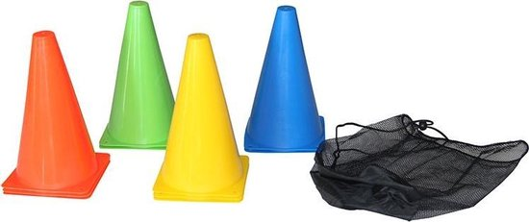

 | WORKOUT 1 | WORKOUT 2 | WORKOUT 3 | WORKOUT 4 | WORKOUT 5 | WORKOUT 6
V CONE DRILL | 2x | 3x | 2x | 2x | 3x | 3x
T CONE DRILL | 2x | 3x | 2x | 3x | 3x | 3x
L CONE DRILL | 2x | 2x | 3x | 2x | 3x | 3x
BOX CONE DRILL | 2x | 2x | 2x | 3x | 3x | 3x
SUICIDE CONE DRILL | 2x | 2x | 2x | 3x | 3x | 3x

