AGILITIE CONE DRILL PROGRAM 1
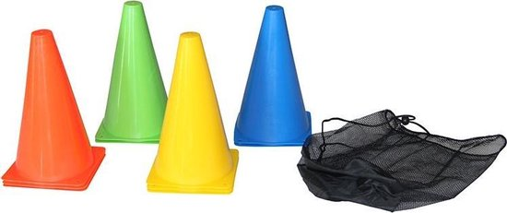

 | WORKOUT 1 | WORKOUT 2 | WORKOUT 3 | WORKOUT 4 | WORKOUT 5 | WORKOUT 6
 | EMOM 60S | EMOM 55s | EMOM 50s | EMOM 45s | EMOM 45s | EMOM 45s
18M SPRINT | 2x | 3x | 2x | 2x | 2x | 3x
5M SIDEWAYS, 5M SIDEWAYS BACK, 18M SPRINT | 2x | 3x | 2x | 3x | 3x | 3x
5M SPRINT, 5M BACKPADLE, 18M SPRINT | 2x | 2x | 3x | 2x | 3x | 3x
18M SPRINT, 5M BACKPADLE, 5M SPRINT | 2x | 2x | 2x | 3x | 3x | 3x
9M SPRINT, 18M SPRINT, 9M SPRINT | 1x | 1x | 1x | 1x | 1x | 1x

