AGILITIE ROPE JUMP PROGRAM 1
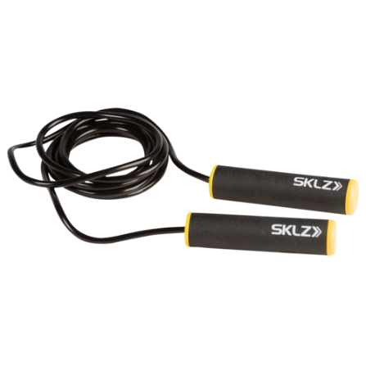
WORKOUT 1 WORKOUT 4
REGULAIR JUMPS 80 REGULAIR JUMPS 1X100
SINGLE LEG JUMPS L 1X30 BOXING STYLE JUMPS 1X100
SINGLE LEG JUMPS R 1X30 DOUBLE UNDERS 3X10
BOXING STYLE JUMPS 2X40 GAME HOW MANY JUMPS IN 40 SECONDS 1X
FORWARDS JUMPS 2X 20M
WORKOUT 2 WORKOUT 5
REGULAIR JUMPS 90 REGULAIR JUMPS 1X120
SINGLE LEG JUMPS L 1X30 BOXING STYLE JUMPS 1X120
SINGLE LEG JUMPS R 1X30 DOUBLE UNDERS 3X12
BOXING STYLE JUMPS 2X40 GAME HOW MANY JUMPS IN 50 SECONDS 1X
FORWARDS JUMPS 2X 30M
WORKOUT 3 WORKOUT 6
REGULAIR JUMPS 100 REGULAIR JUMPS 1X140
SINGLE LEG JUMPS L 1X30 BOXING STYLE JUMPS 1X140
SINGLE LEG JUMPS R 1X30 DOUBLE UNDERS 3X14
BOXING STYLE JUMPS 2X40 GAME HOW MANY JUMPS IN 60 SECONDS
SIDEWAYS JUMPS 4X 15M

