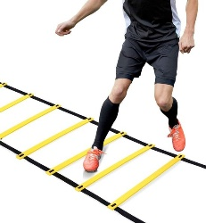
AGILITIE SPEEDLADDER PROGRAM 1

 | WORKOUT 1 | WORKOUT 2 | WORKOUT 3 | WORKOUT 4 | WORKOUT 5 | WORKOUT 6
1 FORWARD IN IN OUT OUT | 2x | 3x | 2x | 2x | 3x | 3x
2 FORWARD IN IN OUT OUT JUMING | 2x | 3x | 2x | 3x | 3x | 3x
3. FORWARD IN IN OUT OUT EXTRA STEP INSDE | 2x | 2x | 2x | 3x | 3x | 3x
FORWARD IN IN OUT OUT EXTRA STEP OUTSIDE | 2x | 2x | 2x | 3x | 3x | 3x
5 SIDEWAYS IN IN OUT OUT 1 BOX | 2x | 2x | 3x | 2x | 3x | 3x
5 SIDEWAYS IN IN OUT OUT 2 BOX | 2x | 2x | 3x | 3x | 3x | 3x
7 2 FORWARD 1 BACKWARDS | 2x | 2x | 3x | 2x | 2x | 3x
8 2 SIDEWAYS BACK 2 SIDEWAYS FORWARD | 2x | 2x | 2x | 3x | 2x | 3x
9 3 STEPS IN A BOX | 2x | 2x | 2x | 2x | 2x | 3x
10 4 STEPS IN A BOX | 2x | 2x | 2x | 2x | 2x | 3x

