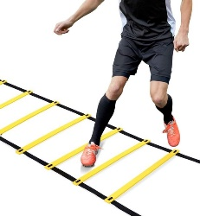
AGILITIE SPEEDLADDER PROGRAM 2

 | WORKOUT 1 | WORKOUT 2 | WORKOUT 3 | WORKOUT 4 | WORKOUT 5 | WORKOUT 6
SINGLE LEG SKIPPING L | 2x | 3x | 2x | 2x | 3x | 3x
SINGLE LEG SKIPPING R | 2x | 3x | 2x | 3x | 3x | 3x
SINGLE LEG SKIPPING SIDE WAYS L | 2x | 2x | 2x | 3x | 3x | 3x
SINGLE LEG SKIPPING SIDE WAYS R | 2x | 2x | 2x | 3x | 3x | 3x
ICKY SHUFFLE | 2x | 2x | 3x | 2x | 3x | 3x
ICKY SHUFFLE DOUBLE TAP | 2x | 2x | 3x | 3x | 3x | 3x
ICKY SHUFFLE BACKWARDS | 2x | 2x | 3x | 2x | 2x | 3x
ALI SHUFFLE | 2x | 2x | 2x | 3x | 2x | 3x
CROSS STEP BACKWARDS | 2x | 2x | 2x | 2x | 2x | 3x
180 JUMPS 90/90 | 2x | 2x | 2x | 2x | 2x | 3x

