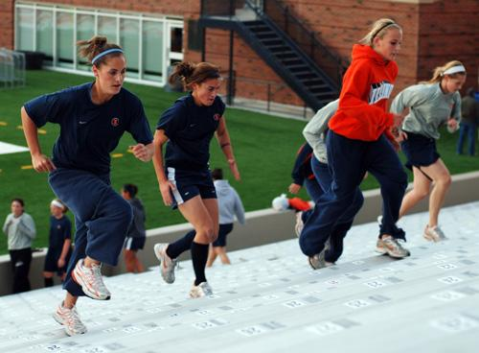
CONDITIONING AROUND THE FIELD PROGRAMMA 1
WORKOUT 1 WORKOUT 4
140S RUNNING 4400S RUNNING
60S WALKING 50S WALKING
140S RUNNING 60S RUNNING
WORKOUT 2 WORKOUT 5
180S RUNNING 480 RUNNING
60S WALKING 60s WALKING
180S RUNNING 90s RUNNING
WORKOUT 3 WORKOUT 6
180S RUNNING 600S RUNNING
60S WALKING
220S RUNNING

