RING PROGRAM
MEDIUM 6
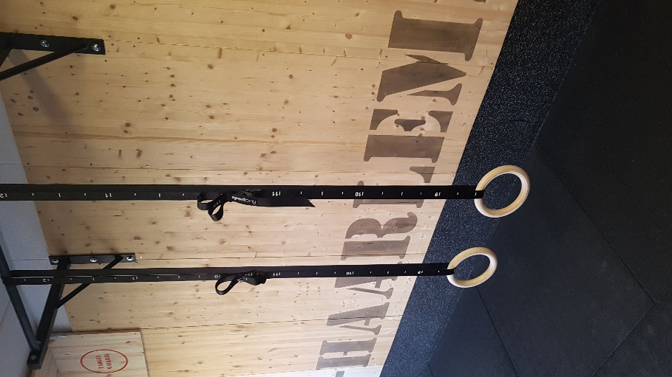
PROGRAM 6
WARMING-UP
MAX OUT | TRAINING 1
1 PULL-UPS | 5 SETS
2 DIPS | 5 SETS
3 KNEE TUCK AND PUNSH | 5 SETS
4 HOW MANY TURN OVERS | 5 SETS
5 HOW LONG CAN YOU REGULAIR HANG? | 1 SET
6 HOW LONG CAN YOU HANG IN PULLUP UP POSITION | 1 SET

