RING PROGRAM
HARD 2
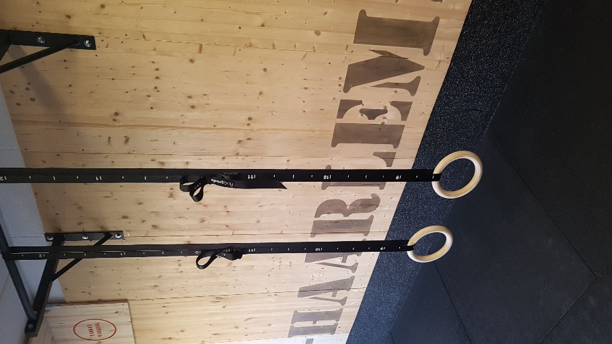
PROGRAM 2
WARMING-UP
SINGLE SETS | TRAINING 1 | TRAINING 2 | TRAINING 3 | TRAINING 4 | TRAINING 5 | TRAINING 6
BAND L-SIT FLOOR PULL UP WHIT TURN TO DIP | 3 SETS | 3 SETS | 4 SETS | 4 SETS | 4 SETS | 5 SETS
PROGRESSION: TRY TO GET EVERY NEW WORKOUT 1 OR 2 MORE REPS IN TOTAL
50 SECONDS REST INBETWEEN SETS

SINGLE SETS | TRAINING 1 | TRAINING 2 | TRAINING 3 | TRAINING 4 | TRAINING 5 | TRAINING 6
L SIT REGULAIR HANG TO WIDE HANG | 3 SETS | 3 SETS | 4 SETS | 4 SETS | 4 SETS | 5 SETS
ARCHER PUSH UPS | 3 SETS | 3 SETS | 4 SETS | 4 SETS | 4 SETS | 5 SETS
FRONT LEVER RAISES | 3 SETS | 3 SETS | 4 SETS | 4 SETS | 4 SETS | 5 SETS
PULL-UPS FALS GRIP | 3 SETS | 3 SETS | 4 SETS | 4 SETS | 4 SETS | 5 SETS
PROGRESSION: TRY TO GET EVERY NEW WORKOUT 1 OR 2 MORE REPS IN TOTAL
50 SECONDS REST INBETWEEN SETS
ARMAP | TRAINING 1 | TRAINING 2 | TRAINING 3 | TRAINING 4 | TRAINING 5 | TRAINING 6
DIPPING  BACK EXTENSION  V-UPS | 8 MINUTES  6 REPS | 8 MINUTES  7 REPS | 9 MINUTES  6 REPS | 9 MINUTES  7 REPS | 10 MINUTES  7 REPS | 10 MINUTES  7 REPS

