RING PROGRAM
MEDIUM 5
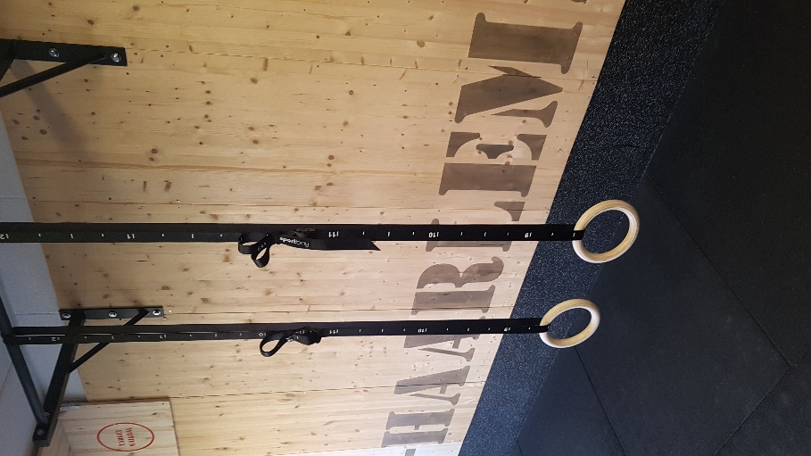
PROGRAM 5
WARMING-UP
SUPERSETS | TRAINING 1 | TRAINING 2 | TRAINING 3 | TRAINING 4 | TRAINING 5 | TRAINING 6
1 LOWERBACK EXTENSION  2 TURN OVERS | 3 SET / 60S 4/4 REPS | 3 SET / 60S 5/5 REPS | 3 SET / 60S 6/6 REPS | 4 SET / 60S 4/4 REPS | 4 SET / 60S 5/5 REPS | 4 SET / 60S 6/6 REPS
1 L-SIT PULL UPS FLOOR  2 KNEE RAISES | 3 SET / 60S 8/4 REPS | 3 SET / 60S 8/5 REPS | 3 SET / 60S 10/5 REPS | 4 SET / 60S 4/4 REPS | 4 SET / 60S 4/4 REPS | 4 SET / 60S 4/4 REPS
1 KNEE TUCK AND PUSH  2 REGULAIR HANGING TO WIDE REPS | 3 SET / 60S 4/4 REPS | 3 SET / 60S 5/5 REPS | 3 SET / 60S 6/6 REPS | 4 SET / 60S 4/4 REPS | 4 SET / 60S 5/5 REPS | 4 SET / 60S 6/6 REPS
1 FLY’S  2 PUSH-UPS | 3 SET / 60S 4/8 REPS | 3 SET / 60S 5/8 REPS | 3 SET / 60S 6/9 REPS | 4 SET / 60S 6/6 REPS | 4 SET / 60S 4/4 REPS | 4 SET / 60S 4/4 REPS

RING ROTATIONS | TRAINING 1 | TRAINING 2 | TRAINING 3 | TRAINING 4 | TRAINING 5 | TRAINING 6
PUSH-UP | 1 SETS 8X | 1 SETS 10X | 1 SETS 12X | 2 SETS 8X | 2 SETS 10X | 2 SETS 12X
REGULAIR HANGING | 1 SETS 8X | 1 SETS 10X | 1 SETS 12X | 2 SETS 8X | 2 SETS 10X | 2 SETS 12X
PULL-UP | 1 SETS 8X | 1 SETS 10X | 1 SETS 12X | 2 SETS 8X | 2 SETS 10X | 2 SETS 12X

